**TICKET VENDING MACHINE**

A ticket vending machine (TVM) dispenses tickets to passenger at a railway station. Passengers use the front panel to specify their Boarding and Destination place, detail of passenger (number of adults & children) and date of travel. The machine displays the fare for the requested ticket. The passenger then deposits cash in the bin provided and presses ‘accepts cash’. The machine check the cash, if it is more, the balance cash is paid out. And the ticket requested is printed. The system is also used by the operator who might want to know the cash held in the machine, the break-up of small changes available in the machine, withdraw or deposit cash when needed. And the report option also included the detailed report of transaction, summary report of the number of tickets sold for each destination, opening balance, cash collected, cash dispensed and current balance in the machine.

1. **USECASE DIAGRAM:**

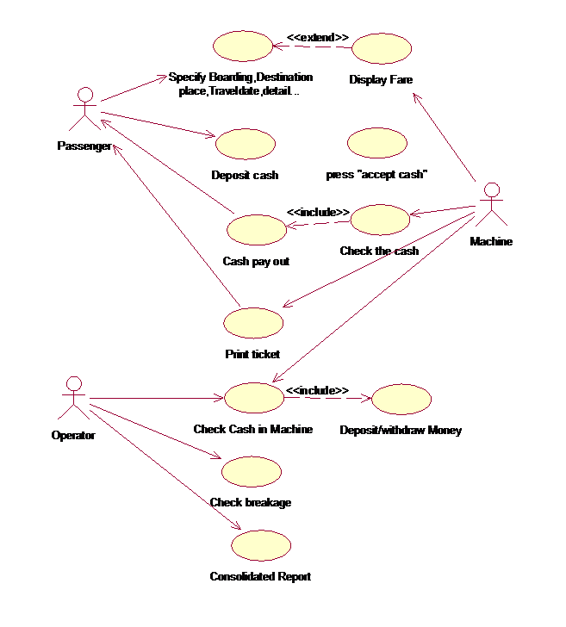

1. **ACTIVITY DIAGRAM:**

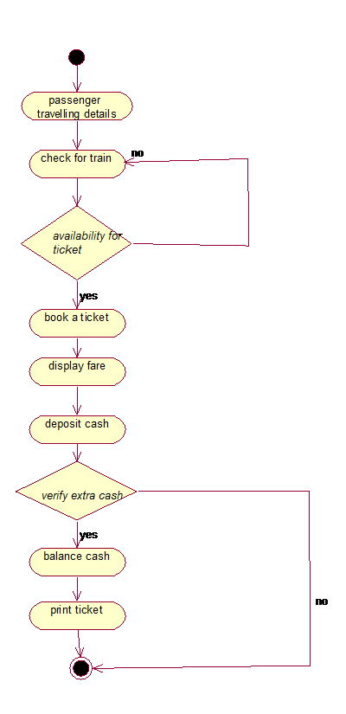

1. **SEQUENCE DIAGRAM:**

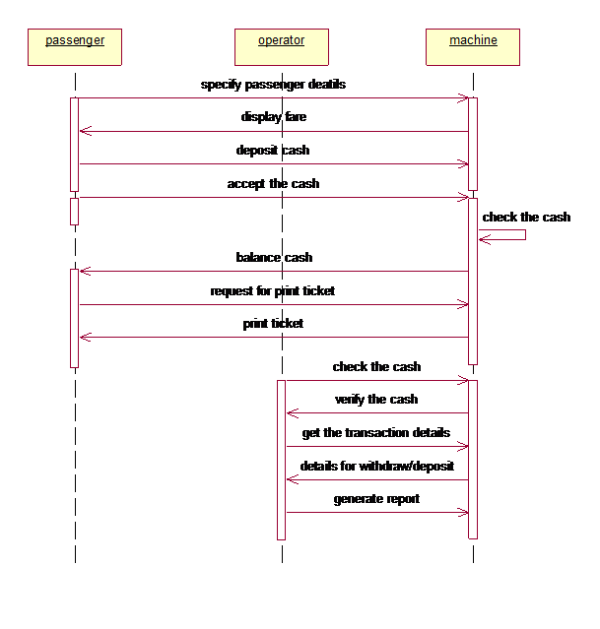

1. **COLLABORATION DIAGRAM:**

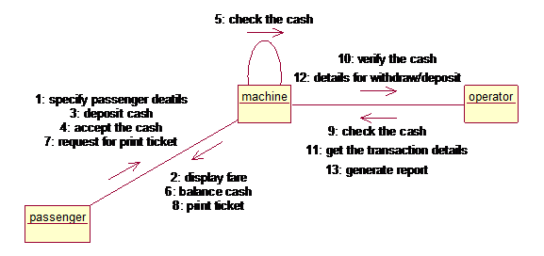

1. **CLASS DIAGRAM:**

